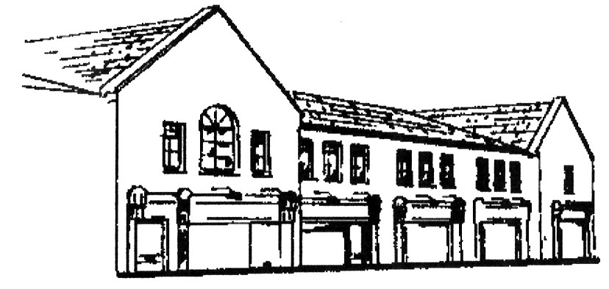
Dunshaughlin Dental Centre
www.dunshaughlindental.com
info@dunshaughlindentalcentre.com
01 8259787

Instructions following extraction of teeth.

- Rinsing:
Do not rinse your mouth out after the extraction as this removes the blood clot which forms the healing tissue. Avoid touching the socket with your tongue or fingers.
After 24 hours, use a hot salty mouthwash regularly for 3-4 days.

- Cleaning:
You should brush the remaining teeth as usual being careful not to touch the socket area.
- Eating and Drinking:
A soft diet is advisable, but eat whatever you can tolerate. Drink plenty of fluids. Do not drink alcohol.
- Bleeding:
If this occurs after leaving the practice, roll a clean paper handkerchief into a pad about the thickness of your finger, place this over the socket and bite in it for 20 minutes. Replace and repeat as necessary.
- Exercise:
Avoid strenuous exercise, as this may bring on bleeding.
- Pain:
Some pain may be experienced after an extraction. Take two paracetomol every 4 hours as necessary.
- Swelling:
Some minor swelling is to be expected after the extraction and may take up to 10 days to disappear.
- Smoking:
Refrain from smoking today

If in doubt about any point please do not hesitate to ask.

