ORTHODONTIC BRUSHING TECHNIQUE.

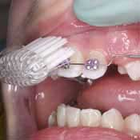 | 1. Brush along the gum line.
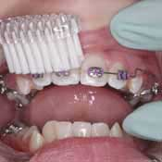 | 2. Brush with the bristles of the toothbrush directed toward the top of the brackets.
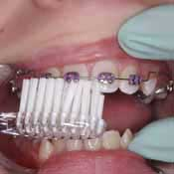 | 3. Brush with the bristles of the toothbrush directed toward the bottom of the brackets.
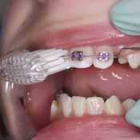 | 4. Brush with the toothbrush by placing the brackets in the groove of the orthodontic brush (the bristles of the toothbrush will be perpendicular to the tooth).
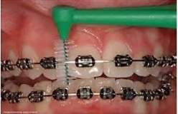 5. Using your green teepee brush clean under the wire.

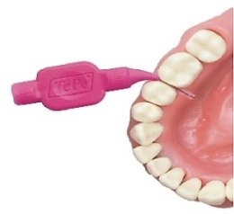 6. Using your pink teepee brush clean in between all your teeth.

