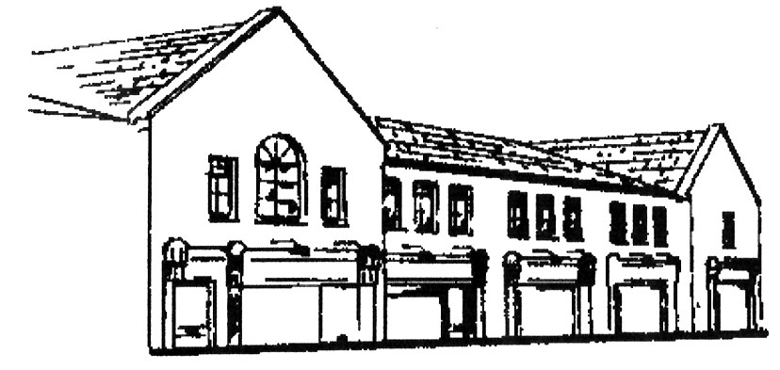
Dunshaughlin Dental Centre
www.dunshaughlindental.com
info@dunshaughlindentalcentre.com
01 8259787

Care of Fixed Appliance

- The appliance is fixed to your teeth and you must not attempt to remove or adjust it.
- Initially it will cause some discomfort, this should not be severe but if you are in doubt please do not hesitate to contact the surgery.
- Sticky sweets, chewing gum, toffee, hard foods, tough meat etc. can damage the appliance so please avoid these types of food.
- The appliance itself will not harm the teeth but damage will occur if it is not kept perfectly clean. The teeth and appliance must be cleaned thoroughly after each meal and just before going to bed. We have provided you with a list of oral hygiene supplies which you will need to purchase for cleaning.
- It is vital that any special instructions, such as wearing elastics are strictly followed.
- The use of a mouth guard during contact sports is recommended. An Opro shield mouth guard for fixed appliance can be purchased from the surgery.

